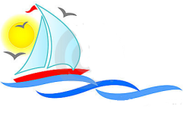
Opdracht 1: Kranten bekijken

1. Welke krant spreekt je het meest aan? Waarom?

__________________________________________________________________________________

__________________________________________________________________________________

__________________________________________________________________________________

2. Schrijf bij iedere krant die jullie bekeken hebben wat jullie opvalt aan deze krant:

a. _____________________________________________________________________

b. _____________________________________________________________________

c. _____________________________________________________________________

d. _____________________________________________________________________

3. Welke vaste onderdelen kom je steeds tegen in de kranten die jullie bekeken hebben?

• ____________________________________________________________________________

• ____________________________________________________________________________

• ____________________________________________________________________________

• ____________________________________________________________________________

• ____________________________________________________________________________

• ____________________________________________________________________________

